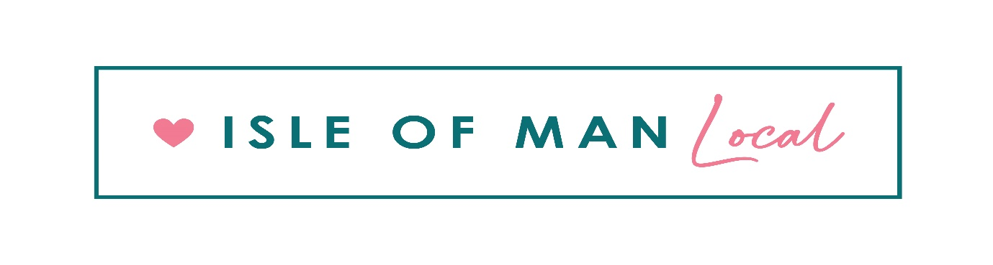
Partner Service Agreement

Company  Isle of Man Local Limited  3 Hughenden Terrace  May Hill  Ramsey  Isle of Man  IM8 2HH |  | Company Contact:  Tel: 07624 234453  Email: info@isleofmanlocal.im

This Partner Service Agreement between Isle of Man Local Limited and the Partner is made up of this Order Form and the ISLE OF MAN LOCAL Standard Partner Terms and Conditions. Capitalised terms shall have the meanings attributed to them in this Order Form and the ISLE OF MAN LOCAL Standard Partner Terms and Conditions as applicable.

Partner Details:

Partner (full legal name): |  |  | Office Address:
Trading as:
Company No:
(if applicable)
Partner Contact: |  |  | Business Address  (if different from Office Address):
VAT no: |  |  | Website address:
Tel: |  |  | Contact Email:
Display Tel:  (if different) |  |  | Display Email:  (if different)

Partner Product/Service:
Partner Product/Service:
Offer Description:
Offer Price (amount paid by consumer):
Offer Value (full value of voucher RRP)
Offer Promotional Discount (%):
No. of Voucher Product offers:
Contract Length
Isle of Man Local Margin
Partner Revenue Share
Redemption Options |  | Telephone -  Email -

Partner Product Details:

Partner Bank Details:

Bank/Building Society:
Account Name:
Sort Code: |  | Account Number:

Partner has received a copy of the Isle of Man Local Standard Partner Terms and Conditions and hereby agrees to its terms.

Authorisation & E-Signing
I confirm that I am an authorised representative of the Partner stated on this document and that my act of e-signing this document shall be a binding commitment of the Partner under the terms of Isle of Man Local Partner Service Agreement Order Form and the ISLE OF MAN LOCAL Standard Partner Terms and Conditions.

EXECUTED by the parties on the 8th day of October 2021 (“the Effective Date”)

SIGNED by

duly authorised for and on behalf of
Isle of Man Local Limited

SIGNED by

duly authorised for and on behalf of
Partner

